**ASSIGNMENT SUBMISSION PROCEDURE THROUGH GITHUB**

**STEP 1:**

* Create an account on GITHUB platform using the URL provided below

**link:** https://github.com/

* Once the account is created with Email ID (Maveric mail id if preferred), Password and Username, Activate the account by providing the validation code that is received over mail.

**STEP 2:**

* Login to the account, Click on **New** to create a new Repository.



* Provide the Repository name.
* Select **PUBLIC** mode so the anyone on the internet can see the repository.
* Select README file with respect to Project description (Use this option if you have done the coding in any other apps/tools like Google colabs).
* Click on create Repository.

Step 3: Post login & repository creation 🡪then go to the google colab 🡪open the assignment notebook 🡪select **File** menu 🡪 click save a copy to GitHub.

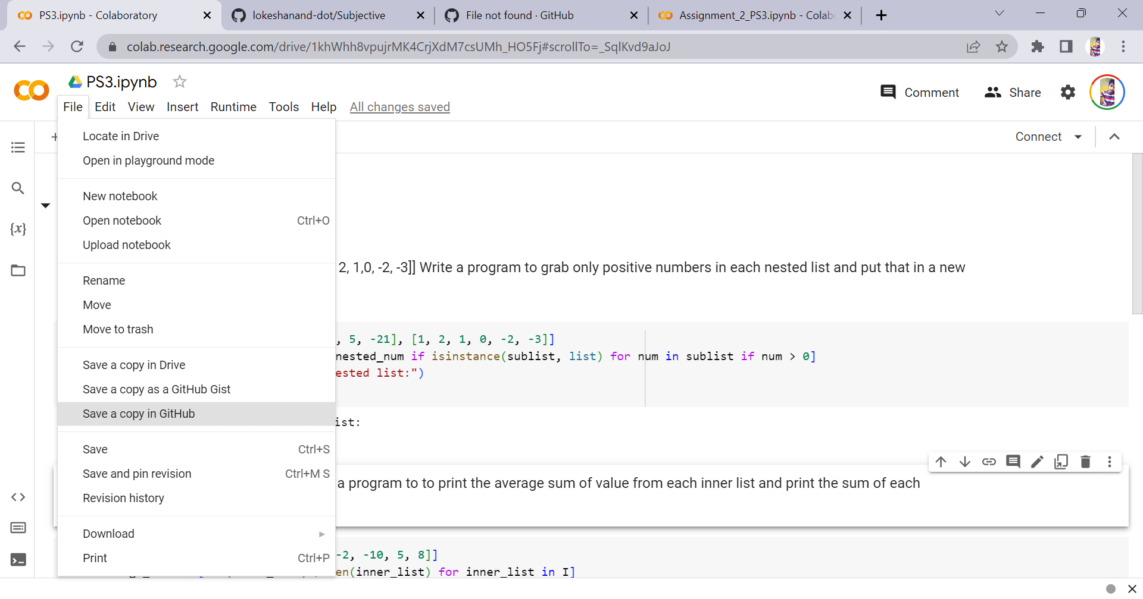

Step 4: New window will be poped up 🡪 Choose the repository of GitHub (where you need to save the file) 🡪 click ok

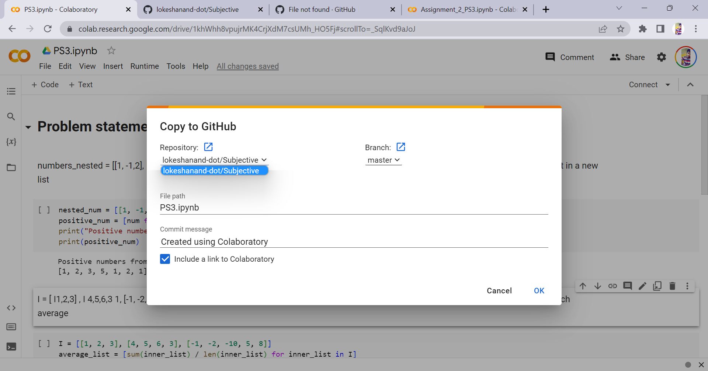

Step 5: open the save file in GitHub repository.

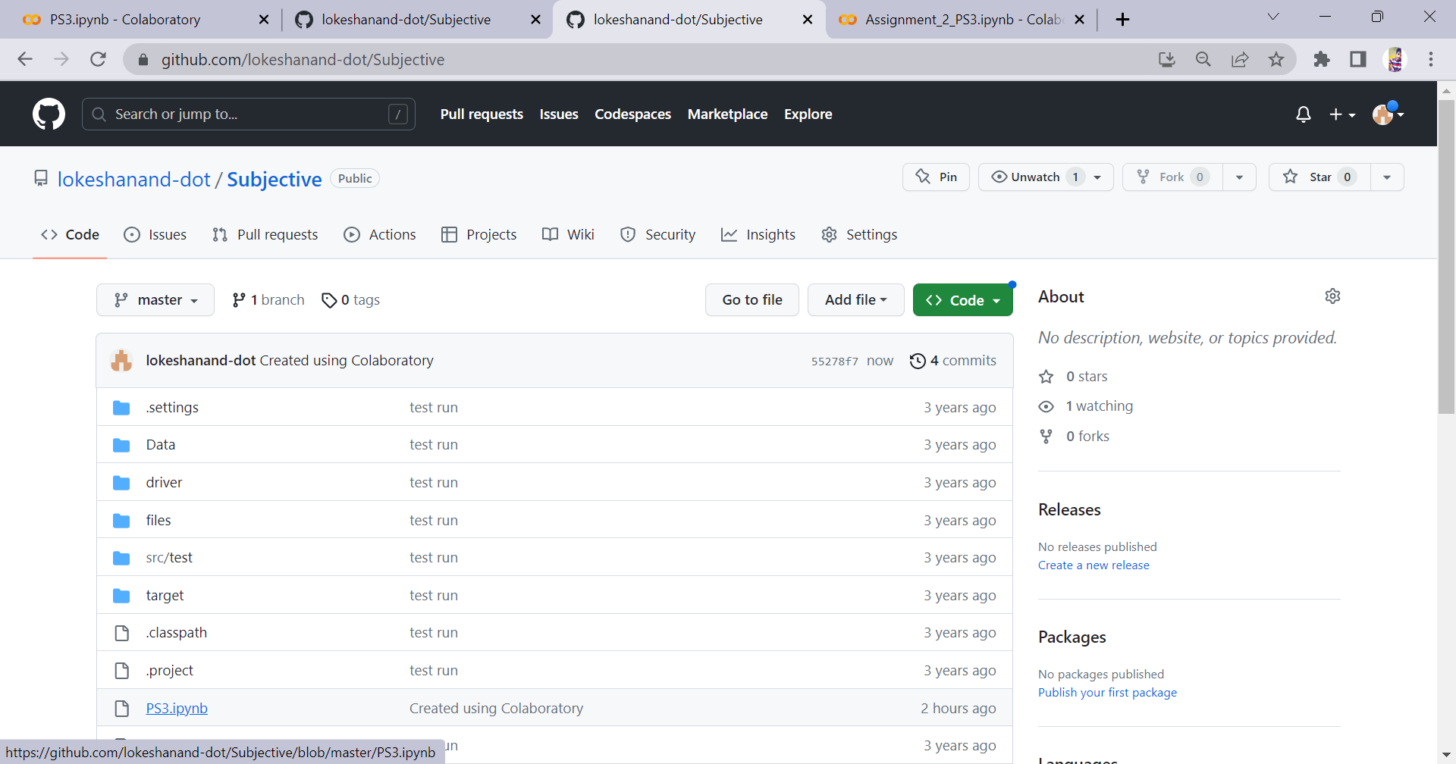

Step 5: Once the file is opened select the 3 dots on the right side of your screen & select copy **Permalink** option.

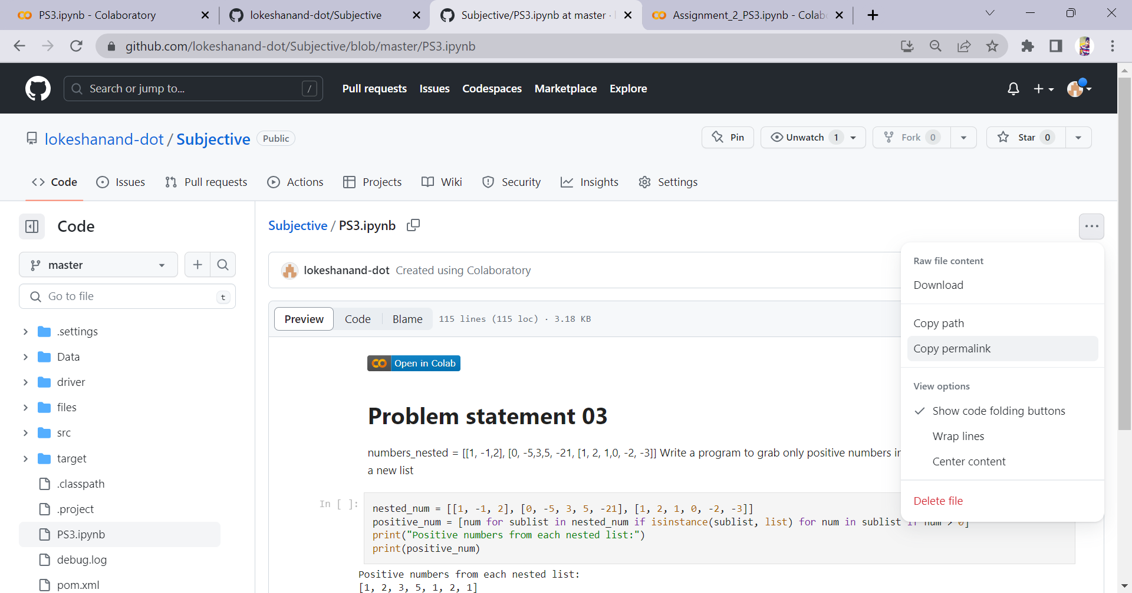

Step 6: Then paste the link in EDYODA classroom for the respective assignment.

Note 1: You can also click on open in colab option to view it in colab from GitHub.

Note 2: Make sure the link is working.